**Experiment No. 1.4**

**Student Name: Rishav Kumar UID: 22MCC20039**

**Branch: MCA - CCD Section/Group: MCD-1/ Grp A**

**Semester: III Date of Performance: 15th Sep 23**

**Subject Name: Business Analytics Subject Code: 22CAH-703**

1. **Aim/Overview of the practical:**

a) Analysis using charts and graphs, chart styles.

b) Changing Chart layouts, add labels, axis options, chart title, legends, data labels.

c) Sharing worksheets and Workbooks using freezing panes.

1. **Code for practical:**

**A.)**

* Open a worksheet with any data.
* Go to the "Insert" tab on the Excel ribbon.
* Click on the type of chart or graph you want to create (e.g., bar chart, line chart, pie chart).
* After inserting the chart, Excel will create a default chart using your selected data.
* You can customize your chart by right-clicking on various elements (bars, axes, titles) and choosing format options or using the "Chart Elements" button on the chart.

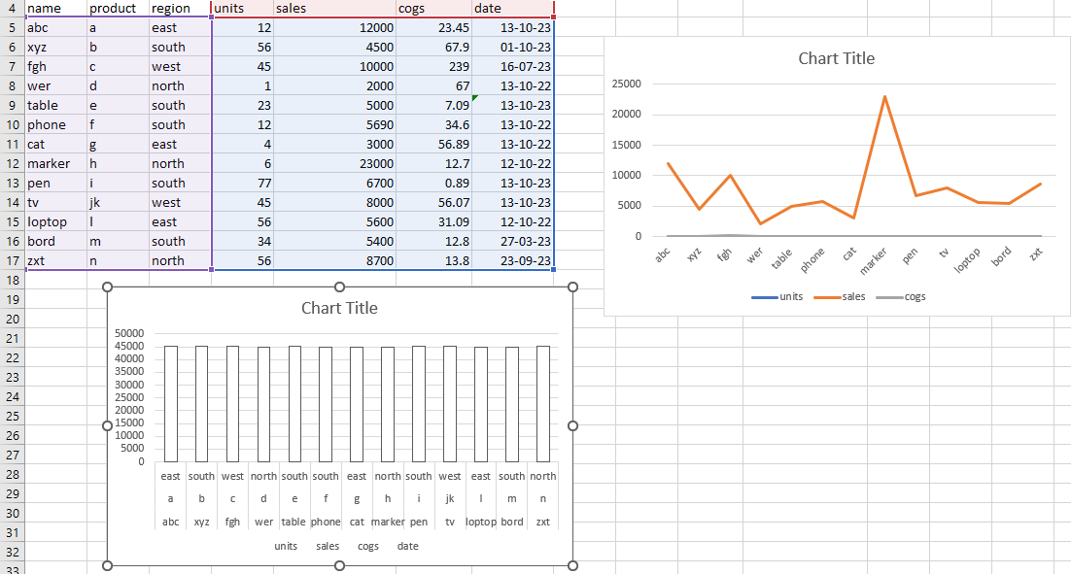

* You can add a title to your chart by clicking on the chart title and typing your desired title.
* Click on the chart to select it.
* In the "Chart Styles" group on the Chart Design tab, you can choose from different pre-defined styles to change the appearance of your chart. These styles affect the colors, fonts, and other visual elements.

**B.)**

* Click on the chart you want to modify. This should make the Chart Tools tabs appear on the Excel ribbon.
* Click on the "Chart Design" tab on the ribbon.
* In the "Chart Layouts" group, you can choose different chart layouts by clicking on the layout thumbnails. These layouts may include different combinations of titles, legends, and data labels.
* To add or edit a chart title, click on the chart title area, which is usually at the top of the chart.

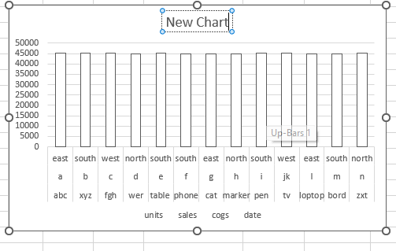

* Start typing your desired title.
* Select the data series (e.g., bars, lines, pie slices) you want to label within the chart.
* Right-click on the data series, then choose "Add Data Labels" or "Data Labels" from the context menu.
* Data labels will appear on the selected data points.

**C.)**

**Sharing a Worksheet:**

* Open your Excel workbook containing the worksheet you want to share.
* Go to the "View" tab on the Excel ribbon.
* In the "Window" group, click on "Freeze Panes."
* A drop-down menu will appear with three options:
* "Freeze Panes" will freeze the selected rows and columns, keeping them visible while scrolling.
* "Freeze Top Row" will only freeze the top row.
* "Freeze First Column" will only freeze the first column.
* Select the desired option based on what you want to freeze. For example, if you want to keep the top row and the first column visible, select "Freeze Panes."

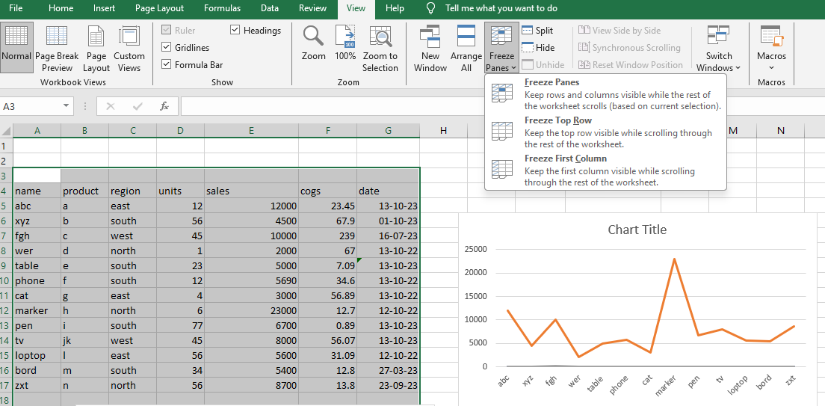

* The selected rows and columns will be frozen, and you can scroll through the rest of the worksheet while keeping these areas visible.

**Sharing a Workbook**

* Open your Excel workbook.
* Go to the "File" tab.
* Click on "Share" in the left-hand menu.
* You can choose to share the workbook via email, cloud storage services, or by generating a sharing link. Select the option that suits your needs.
* Follow the prompts to share the workbook, whether by entering email addresses, setting permissions, or creating a link.

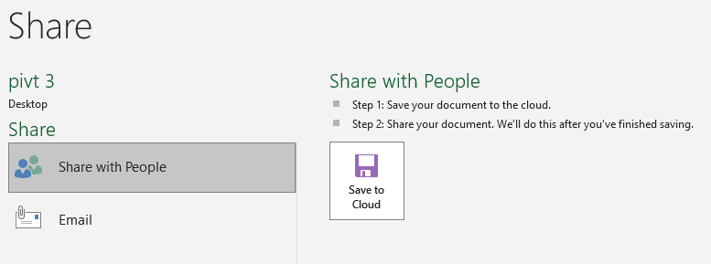

* You can also set up sharing preferences, including whether others can edit or only view the workbook.
* Once shared, collaborators can access the workbook and make edits simultaneously.
* To protect the workbook and control who can edit it, you can use Excel's sharing and protection settings in the "Share" and "Review" tabs.

**************************************** **THE END** ***********************************************